**NAME:**

**PROBLEM 1:** Answer the following questions for the beam shown below.



**1a.** Using the diagram on the next page draw the shear, bending moment, curvature, and deflection diagrams. Make sure to point all maximums, minimums, points of inflections, boundary conditions, critical point values, critical locations, and location of the maximum deflection.

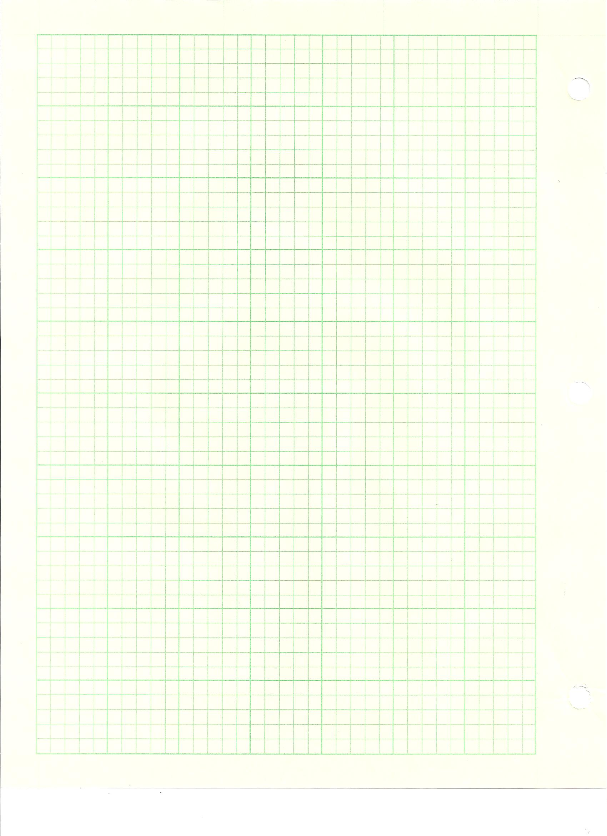



**1b.** Using the beam bending tables provided determine the reactions at A and D, and the deflections at B andC. Identify and Illustrate the beams used in the solution on the figure provided below.





**1c.** Write a general expression for the load, shear, bending moment, curvature, and deflection of the beam. Make sure to calculate all constants. Using these equations determine the deflections at B and C.

**PROBLEM 2:** A strain gage rosette is used on a pressure vessel that is 20 inches in diameter and has a wall thickness of 0.25 inches. The pressure vessel is made of steel (E=10x106 psi, ν=0.3). The three gage’s on the rosette are positioned 45° apart and the gage was attached prior to any pressure being placed in the vessel. After pressurization the gages are read in a counter-clockwise manner (a-b-c), corrected for transverse sensitivity, and read as follows:

εa=229x10-6

εb=81x10-6

εc=121x10-6

Using the grid paper on the next page construct Mohr’s circle for strain, determine the principal strains, find the angle that the gages are offset, and determine the pressure in vessel by using both the axial and circumferential stresses.

